2-3 Milestone One: Project Proposal

Farrik Barnard

1.

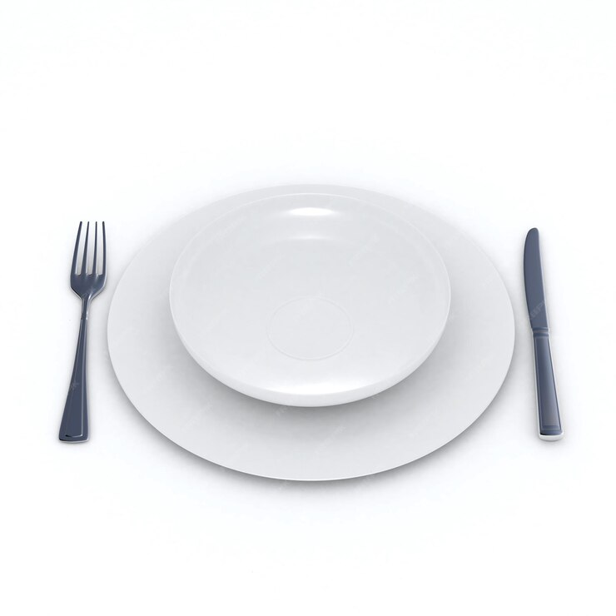

2. I have a pretty simple picture. I think I can replicate the entire image. The plates will be good to work with and the silverware will be a nice challenge to replicate.

3. I can use cylinders for the plates. I can use a cone and a box for the fork. The knife I can use a box shape. My guess will I will have to trail and error to get the best shape for each image.